## Dominic Zottolo­

## MI 349

## Week 7 Card Sort

## October 26, 2016

Week 7 Card Sort

For the card sorting exercise I used the cards that I created previously. The directions stated that the cards should be content chunks as opposed to pages. Because of this I created additional cards that combine Facebook, Twitter, Instagram, YouTube as simply Social Media or Other Links. I left in the other cards for the sort because I wanted to see how others would organize the cards with the additional links. Another example of this would be contact info which could combine Address, Phone Number, etc. My first and second card sorts returned the same results and are shown below.

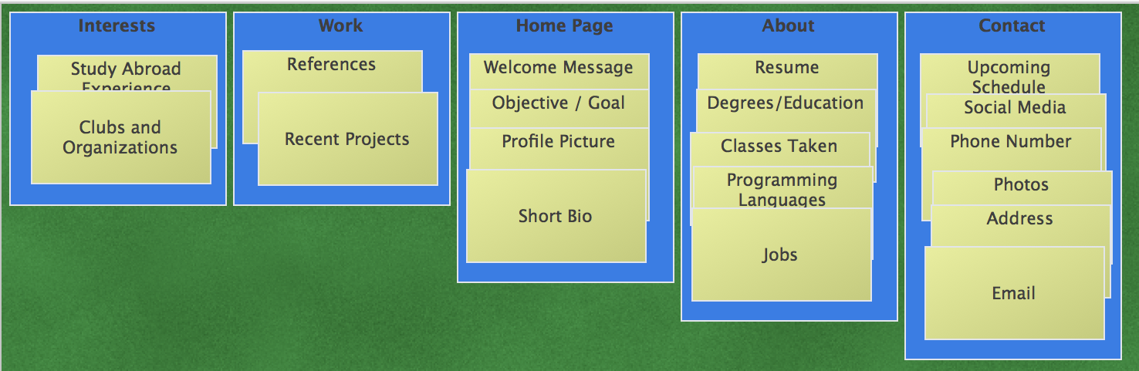

Dominic’s Open Card Sort

I created five groups to sort the cards that I had. The first being the Home Page card which the user first sees when coming to my site. This includes a welcome message and other cards which help the user get to know some initial information about me, and then the user can click on the other groups to get further information. I wanted a work group where I can showcase the projects that I have worked on and as well as an interests tab so that the user can get a sense of the type of person I am. I figured that five groups were sufficient for a portfolio website.

When considering a persona with the sort, I began to question the difference between the “About” and “Contact” information as some of this may overlap or be included in both groups. Also, I was considering adding a group for Site Functionality for a Search feature so that the persona does not need to have a difficult time finding exactly what they are looking for.

Paige was asked to do an Open Card Sort where she could arrange the cards in her own groups. She came up with 3 groups where there is a main page, contact, and about. She did not know that I wanted my own groups to showcase the work that I have done, so she put it all in the contact / about sections. I had Andrew do a Closed Card Sort using the same groups that I determined previously. He had similar results to mine with only slight changes.

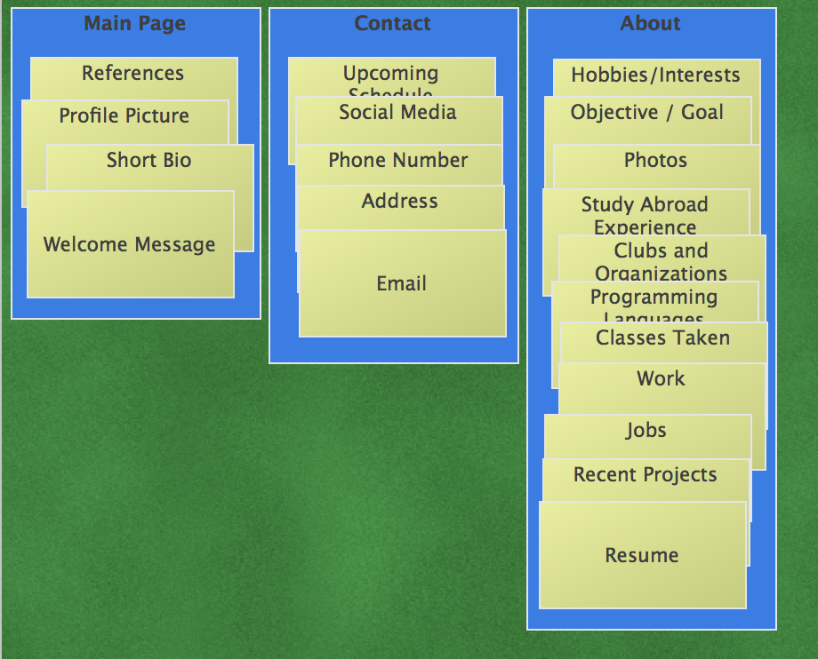

Paige’s Open Card Sort

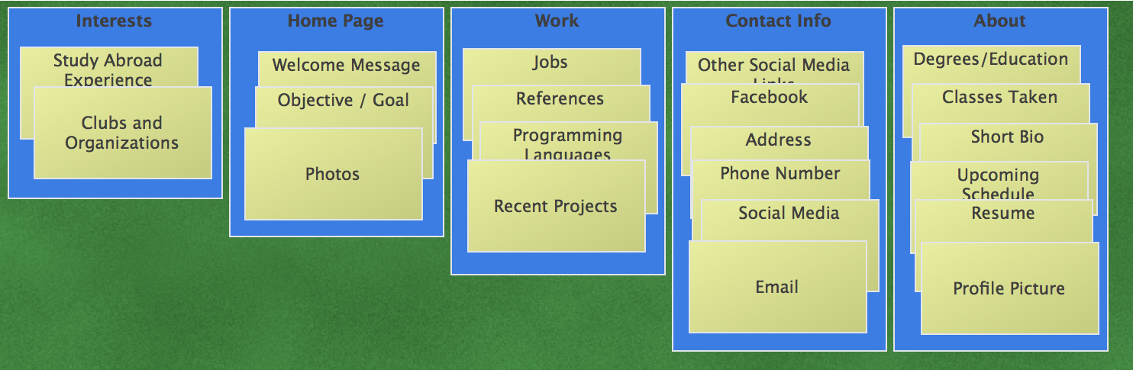

Andrew’s Closed Card Sort